**Project Design Phase-II**

**Data Flow Diagram & User Stories**

|  |  |
| --- | --- |
| Date | 03 October 2022 |
| Team ID | PNT2022TMID47478 |
| Project Name | Project – SMART SOLUTION FOR RAILWAYS |
| Maximum Marks | 4 Marks |

**Data Flow Diagrams:**

A Data Flow Diagram (DFD) is a traditional visual representation of the information flows within a system. A neat and clear DFD can depict the right amount of the system requirement graphically. It shows how data enters and leaves the system, what changes the information, and where data is stored.

Example: DFD Level 0

**Example:** [**(Simplified)**](https://developer.ibm.com/patterns/visualize-unstructured-text/)

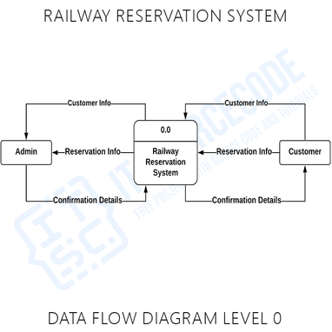

**](https://developer.ibm.com/patterns/visualize-unstructured-text/)**



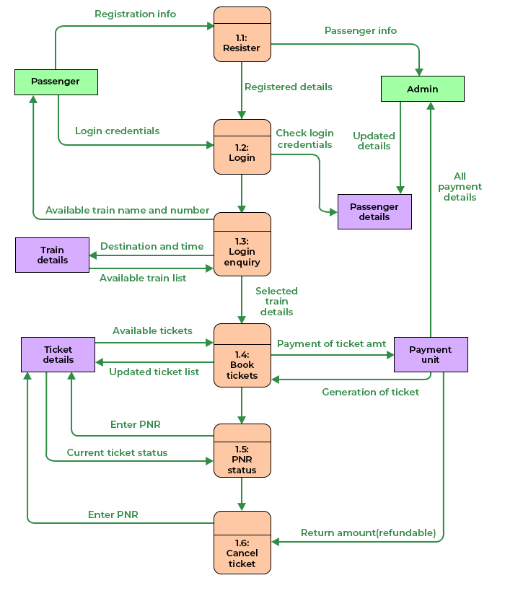

**User Stories**

| **User Type** | **Functional Requirement (Epic)** | **User Story Number** | **User Story / Task** | **Acceptance criteria** | **Priority** | **Release** |
| --- | --- | --- | --- | --- | --- | --- |
| Customer (Mobile user) | Registration | USN-1 | As a user, I can register for the application by entering my email, password, and confirming my password. | I can access my account / dashboard | High | Sprint-1 |
| Customer (Mobile user) | Registration | USN-2 | As a user, I will receive confirmation email once I have registered for the application | I can receive confirmation email & click confirm | High | Sprint-1 |
| Customer (Mobile user) | Registration | USN-3 | As a user, I can register for the application through Facebook | I can register & access the dashboard with Facebook Login | Low | Sprint-2 |
| Customer (Mobile user) | Login | USN-5 | As a user, I can log into the application by entering email & password | I can log into the application by entering email & password | High | Sprint-1 |
| Customer (Mobile user) | Dashboard | Users | The details will be stored safely | I can access it using  database | Medium | Sprint-3 |
| Customer (Web user) | Reserving ticket | User | Enter the details and click submit button to  book ticket | I can use the QR code  which is been generated | High | Sprint-1 |
| Customer Care Executive | Connecting the  service provider | Customer | Connects with the service by logging in | Can get connected with  the server | Medium | Sprint-3 |
| Administrator | Provides the  services | Admin | The data is given by the user | Can add or update the  data provided by the user | High | Sprint-1 |